***Computer Organization***

**Lab 2 Report**

***Names:***

**عبد الرحمن إسماعيل محمد حسن (22010866)**

**نور الدين اكرم السيد كامل سيف (22011309)**

**Objective**

The objective was to design and implement a system using the Arduino UNO that simulates the traffic light pedestrian push button.

**Specification**

At any given time only one LED is active, A LED stays active until the push button is pressed at which point both LEDs toggle.

**Components and Tools**

* Arduino UNO microcontroller board.
* 2 LEDs, red and green for visual indication.
* One resistor for each LED to limit the current.
* Push button for sending input signals.
* Jumper wires for circuit connections.
* Breadboard for building the circuit.
* Arduino IDE for programming the microcontroller.

**Design Decisions and Assumptions**

A four-state system was designed to provide buffering when the push button is held down for an extended period, preventing repeated toggling of the LEDs during continuous button presses.

*State Diagram*

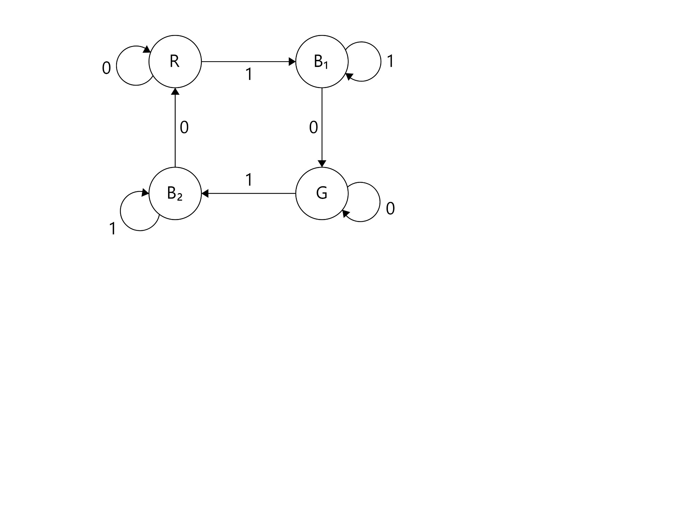

An input signal of 1 indicates that the push button is pressed, An input signal of 0 indicates that the push button is not pressed.

*State Description and Reperesntation*

|  |  |  |  |
| --- | --- | --- | --- |
| **State** | **Color** | **Interal Representation** | **Description** |
| R | Red | 0 | Red State |
| B1 | Green | 1 | First Transition Buffer |
| G | Green | 2 | Green State |
| B2 | Red | 3 | Second Transition Buffer |